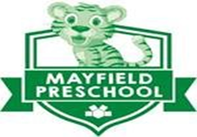
Parent Handbook
2023-2024
Mayfield Preschool
6116 Wilson Mills Rd Door 9A
Mayfield Village, OH 44143
Phone: (440) 995-7300
Fax: (440) 995-6805
Ohio Department of Education
Preschool Programming Licensing Rules
www.mayfieldschools.org

Mayfield Preschool
6116 Wilson Mills Road Mayfield Village, OH 44143
Phone: 440-995-7300 Fax: 440-995-6805
www.mayfieldschools.org
Dear Parents,
WELCOME to Mayfield Preschool, home of the Wildcat Cubs! This handbook has been prepared especially for the parents and children of Mayfield Preschool. The purpose of this handbook is to acquaint you with the preschool program, and ensure you are better informed regarding the daily operations and policies necessary for our operation. This handbook will give you the information necessary to help your student have a successful preschool experience at Mayfield’s Preschool.
As your child is our most important concern, much of what is provided in this handbook is to help in providing your child with a foundation for a good school year.
The staff at Mayfield Preschool will be working to ensure that this year will be an exciting and rewarding experience for your child.
Welcome to Mayfield Preschool!!!
The Early Childhood Enrichment Center is an equal opportunity provider. “In accordance with Federal law and U.S, Department of Agriculture policy, this institution is prohibited from discriminating on the basis of race, color, national origin, sex, age, or disability. To file a complaint of discrimination, write USDA, Director, Office of Civil Rights, 1400 Independence Avenue, SW, Washington, D.C. 20250-9410, or call (800) 795-3272 (voice) or (202) 720-6832 (TTY). USDA is an equal opportunity provider and employer.”
TABLE OF CONTENTS
Letter from the Preschool Coordinator . . . . 2
Governing Board . . . . . . . . 4
Vision & Mission . . . . . . . 4
Philosophy . . . . . . . . . 4
Eligibility of Student . . . . . . . 5
The Preschool Program . . . . . . . 6
Assessment . . . . . . . 8
Class Size . . . . . . . . . 8
Safety of Children . . . . . . . . 8
Contagious Disease . . . . . . . 10
Nurse . . . . . . . . 10
Medical Policy . . . . . . . . 12
Hearing Screening . . . . . . . 13
Emergency Medical Authorization . . . . 13
Health check Services for Children . . . . . 14
Diapering . . . . . . 15
Child Abuse and Neglect Policy . . . . . 15
Sample Schedule . . . . . . . . 16
Arrival and Dismissal. . . . . . . . 17
Transportation . . . . . . . 18
Attendance . . . . . . . . . 19
Snack . . . . . . . . . 19
Behavior . . . . . . . . . 20
Sharing Information. . . . . . . . 20
Change of Address . . . . . . . 20
Parent Involvement . . . . . . . 21
Mayfield Website and Infinite Campus . . . . 21
School Closing . . . . . . 22
Withdraw . . . . . . . 22
Other Information . . . . . . 22
GOVERNING BOARD
Mayfield Preschool program is governed by the Mayfield City Schools Board of Education.
MAYFIELD CITY SCHOOLS
Vision: A promise for learning, dignity and respect for all
Mission: Every Student, Every Day
Mayfield Pillars:
Student Learning and Academic Excellence
Growing Leadership, Talent & Professional Capacity
Fiscal Stewardship and Operations
Community Relations and Family Partnerships
Core Values:
A belief in education as a life-long process
A commitment to the education and development of the whole child
Respect and value of every stakeholder
Open and honest collaboration
A commitment to creating and maintaining a positive and working environment for all
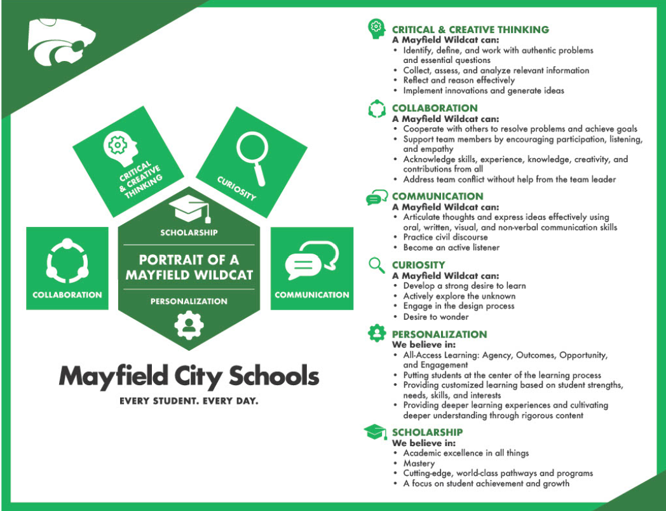

PRESCHOOL PHILOSOPHY
The educational philosophy of Mayfield Preschool is based on a developmental approach to education. Programming is planned to meet each child’s social, emotional, cognitive, language, and physical needs as the child passes through predictable and sequential stages of development.
Child-directed, teacher-supported exploration and learning experiences are designed so that the children can construct knowledge at their own developmental level and pace. This constructivist model allows children to become active participants in the learning process. Trust, social interaction, and play are seen as the foundations on which children develop problem-solving skills, language, and self-esteem.
Integrated programming allows all typically developing children and children with special needs to gain a broader perspective of the real world. Children engage in a variety of opportunities and experiences as they interact with peers in the environment.
Families are considered an integral part of the learning experience. We believe in creating partnerships with families to foster an optimal learning environment; communication is valued. They are encouraged to be active participants in their child’s educational program.

ELIGIBILITY OF STUDENTS
Children with Special Needs
Children who have an identified disability or are in need of a referral for such identifications follow a process through the School Psychologist. All students are 3 years of age before entering the program. Eligibility is determined by the Rules for the Education of Preschool Children with Disabilities Served by Public Schools (Chapter 3301-31). Our program follows mandated state and local placement procedures. A team of staff professionals reviews the needs of each child to determine the appropriate placement.
Peer Models
Peer models are eligible for participation in the program at the age of 3 by August 1, 2023 thru 5 years old. Our placement procedure requires that each prospective student participate in Peer Screening. The following traits are considered:
1. The ability to comply with teacher request in a timely manner
2. Age-appropriate play skills
3. Good language, speech, and communication skills
4. Must toilet independently
5. Demonstrate age-appropriate independence and initiative
6. Demonstrate age-appropriate self-help skills
7. Have the ability to make transitions and flexibility in following directions

Once a child has participated in the peer screening process, and has been accepted into the program, we will send an email notifying the parent of the following:
a. Sign the enrollment contract for the 2023-2024 school year
b. Pay a non-refundable deposit of $290
c. Complete the online student registration
d. Tuition for Mayfield Preschool 2023-2024 Year is $2,610
4 payments of $580 due August, October, December and February

THE PRESCHOOL PROGRAM
The primary goals of the program are to facilitate and provide experiences meeting the Ohio Department of Education Early Learning Program Guidelines.
All Children Are Ready To Learn
- Families are encouraged to provide their child with a good breakfast and good night’s sleep.
- The district nurse reviews health records; staff performs vision and hearing screenings.
- Health, physical and nutritional needs meet state requirements.
Environments Matter
- Provide an environment that respects children.
- Foster the development of positive self-esteem.
- Offer opportunities for children’s active exploration of their environment through play.
- Model and promote opportunities for large motor activities and healthy nutritional choices.
- The physical environment includes materials and equipment to meet the diverse learning needs of the children.
- Play materials encourage children to engage in manipulations, exploration, transform from real to pretend, and collaborate with others in developing play themes.
- Play materials avoid stereotypic play themes; rather, they encourage children to explore a variety of roles and themes.
- Materials provide multiethnic, multicultural, non-stereotypical emphases.
- A variety of sensory materials are available to children including sand, water, paint, and a variety of textures, colors, sounds, and smells.
- The learning environment promotes conceptual development in all children.
Relationships Are Influential
- Support and promote positive relationships with peers and adults.
- Adults are responsive to child-initiated communication, engage in meaningful tasks, and encourage meaningful conversations.
- Learning takes place in a social context; children have many opportunities to learn and practice social and problem-solving skills with their peers.
- Children’s ideas are solicited and valued.
- Interactions between adults and children and among children are a central component of an early childhood curriculum.
Communication Is Critical
- Strengthen the relationship between families and school.
- Foster opportunities for children to demonstrate responsibility, respect, perseverance to complete tasks, pride in their work, and compassion for others.
- Families have meaningful opportunities to provide input regarding their children’s goals.
- Families and teachers regularly confer about children’s developmental progress.
CURRICULUM
Curriculum is an interactive process involving children, families, teachers, administrators, and the community. The Ohio Early Learning Content Standards guide our instructional decisions. Parents, teachers, and community business people developed these standards. Mayfield Preschool takes pride in providing a personalized, and developmentally appropriate curriculum that is differentiated for students and aligned to the standards providing rigorous learning experiences.
- Activities reflect the diverse cultural groups and individuals in the community and society.
- Provide individual skill development for special needs students.
- Plan and implement a wide variety of multi-age, multi-level materials and activities.
- Children have substantial uninterrupted blocks of time to engage in self-selected activities.
- Children are engaged in a combination of child-directed, teacher-directed and adult facilitated activities.
- The Curriculum is carefully planned to provide a warm, nurturing, safe environment for the children attending the preschool, and the standards are implemented through the Creative Curriculum.
- All materials and curriculum are carefully chosen to support the child’s growth cognitive, physically, emotionally, socially and creatively, developing the whole child.
- Ipads and technology are available for use in the classroom.
RECOGNITION OF DEVELOPMENTAL STAGES
Recognizing that children develop at different rates in predictable sequences is critical for planning successful learning experiences and sequential learning that builds on the foundational and developmental needs of students. We encourage growing academic, independence, and self esteem through rigorous, exploration and explicit instruction across the curriculum and developmental learning domains set in the standards; these are taught within each child’s zone of proximal development.
- 3 year old description-Focused on themselves, and meeting their needs with immediacy. Motor skills (both fine and gross motor) are still developing. Attention spans are minimal in duration and childrens’ language skills are developing at a quick rate. Play is parallel and sharing is difficult, still needing taught; students learn through exploration and investigation and manipulating materials through hands-on learning.
- 4 year old description - Enjoys being social and is developing friendships. Motor skills continue to develop through exploration and are advancing to be able to run, jump, and climb with purpose and intention, navigating their environments with ease. Fine motor skills continue to develop as well as students increase focus and attention to detail. Four years olds like to be admired for accomplished tasks and demonstrate the ability to concentrate, set goals, and carry out planned tasks to completion. Feelings are expressed through actions and words.
- 5 year old description - 5 year old students can play well with others, and are concerned with rules and order. Reporting (or tattling) may arise when students see unsafe behavior and others not following directions. Both fine and gross motor skills are continuing to develop from that of a 4 year old. Students are inquisitive about facts, use of items, materials and equipment and want to express their independence and competence. Most five year olds are interested in numbers, counting, printing and beginning reading skills. They are ready for more teacher directed work for longer durations.
ASSESSMENT
Assessment is an ongoing process of gathering information relative to children’s development. That information is coupled with norms for child development in planning an appropriate curriculum.
- Assessment procedures involve utilizing multiple information sources about the child’s development.
- The range of normative development is considered,
- Each child’s rate and expression of development serves as a base for planning an appropriate program.
- Observational strategies assess the children’s progress.
- Assessment results are communicated to families on a regular basis.

CLASS SIZE
The maximum number of children enrolled per classroom is 16-24. Each class consists of peer models and students with special needs. Each classroom is a multi-age grouping, serving children ages three through five.

SAFETY OF CHILDREN
- Children will be supervised by the necessary number of faculty members at all times throughout the day to maintain ratio.
- The outside play area will be supervised so that all children are visible to a member of the teaching staff at all times. Children will be supervised going to and coming from the outside play area and the classroom.
- Immediate communication via walkie-talkies and Red Bags for various situations
- Emergency & Safety Drills are performed throughout the year as mandated by law.
The Mayfield Preschool Emergency Operations Plan (EOP) provides policies and procedures on how to respond to all-hazard emergency incidents. This plan has been customized to meet the specific and unique needs, capabilities and circumstances for Preschool. All staff members participate in multiple training and adhere to all policies set forth by the district.
Student safety is our number one priority at Mayfield City Schools. We will continue to institute processes that enhance our safety practices. The district uses a management system for visitors entering every school building. The system utilizes a government issued ID which is scanned through a national database. The following process will be followed:
1. A State or Government picture identification is required such as a driver’s license. After the State or Government ID verification and background check, a school district employee will provide the visitor with a badge containing their name, their picture, the date and reason for visit.
2. The visitor will be instructed to wear the badge so that it is clearly visible at all times during their visit.
3. Teachers, the buildings’ School Resource Officer, and staff may question any person within the building that is not properly identified and escort them immediately to the main office.
This is another valuable step in keeping our students, teachers and staff safe. We thank you for your continued support and cooperation.
HEALTH INFORMATION
Nurse information
Please see Student Health Services. A registered nurse or health aide is available every day. Their duties are to provide first aid and acute illness care, maintain health records, conduct health screenings, check immunization records, confer with parents and teachers and make referrals, as appropriate. She is not allowed to diagnose or treat illnesses. A portion of the current Preschool conference room will be used as a nurses station. In the event that a student gets ill during the school day, a classroom paraprofessional will escort them to the nurses station and remain with them until a parent / guardian picks them up. The paraprofessional will, then, be responsible for cleaning the space.
Contagious Diseases
Parents should not send their child to school when any signs or symptoms of illness, and especially of contagious disease, are present. Some of these signs and symptoms are fever, rash, vomiting, diarrhea, sore throat, evidence of lice or scabies, severe cough, drainage from eyes or pink eyes, drainage from skin lesions, yellowish skin or eyes, stiff neck, etc. Parents are urged to examine their child before sending him/her to school for signs and symptoms of illness and keep him/her at home when in doubt. Please be considerate and keep your child home if he/she is having significant amounts of nasal discharge and is unable to properly deal with the congestion on his/her own. This will keep the classroom environment healthier for all. Diarrhea will be defined as more than one liquid stool in a day and, unless otherwise explainable, will be considered a sign of illness and the child should not come to school until diarrhea free for 24 hours or will need to be picked up from school should it occur. Preschool staff will dispose of heavily soiled underpants due to diarrhea.
Parents must telephone or email the school when their child is absent. It is imperative you report contagious diseases such as strep, head lice, pink eye, chicken pox and consult their physician about when it will be appropriate for the child to return to school. For bacterial infections, 24 hours of antibiotic treatment is a minimum for return to school. Contact the School Nurse for information on “return to school” after such an illness or any hospitalization. Children returning with splints or casts will need a medical statement from a healthcare provider regarding return to school.
COMMUNICABLE DISEASE
It is our policy to follow the recommendations of the Ohio Department of Health when dealing with potential Communicable Diseases.
ODE policy 3301-37-11 B 2 A child with any of the following signs or symptoms of illness shall be immediately isolated and discharged to his parent or guardian: a. Diarrhea (more than one abnormally loose stool within a 24 hour period; b. Severe coughing, causing the child to become red or blue in the face or to make a whooping sound; c. Difficult or rapid breathing; d. Yellowish skin or eyes; e.,swelling or inflammation of the conjunctiva, the thin, transparent layer of tissue that lines the inner surface of the eyelid and covers the white part of the eye; f. Temperature of 100 degrees fahrenheit taken by the auxiliary method when in combination with other signs of illness; g. Untreated infected skin patch(es); h. Unusually dark urine and/or gray or white stool; or i. Stiff neck; or j. Evidence of lice, scabies or other parasitic infestation, Sore Throat or difficulty swallowing or vomiting more than one time or when accompanied by any other sign or symptom of illness.
ISOLATING AND DISCHARGING AN ILL CHILD
ODE policy 3301-37-11 B 3 A child with any of the following signs or symptoms of illness shall be immediately isolated from other children. The child, while isolated at the program, shall be carefully watched for symptoms listed above as well as the following: (a) unusual spots or rashes (b) sore throat or difficulty in swallowing; (c) elevated temperature; or (d) vomiting.
ODE policy 3301-37-11 B 5 A child isolated due to suspected communicable disease shall be: a. Cared for in a room or portion of a room not being used in the preschool program; b. Within sight and hearing of an adult at all times. No child shall ever be left alone or unsupervised; c. made comfortable and provided with a mat. All linens and blankets used by the ill child shall be laundered before being used by another child. After use, the mats shall be disinfected with an appropriate germicidal agent, or, if soiled with blood, feces, vomit, or other body fluids, the cots shall be cleaned with sap and water and then disinfected with an appropriate germicidal agent; d. Observed carefully for worsening conditions; and e. Discharge to parent, guardian, or person designated by the parent or guardian as soon as practical.
ODE policy 3301-37-11 C 4 Mildly Ill Child Procedures. A “mildly ill child” means a child who is experiencing minor common cold symptoms, but who is not exhibiting any of the symptoms specified above or a child who does not feel well enough to participate in activities, but who is not exhibiting any of the symptoms specified above. If a child is deemed as mildly ill he/she will be monitored by classroom staff for a time period of 30 minutes. If the child continues to meet the criteria for mildly ill parents will be contacted and asked to pick up the child. The child will be supervised in an area removed from the rest of the student and staff (sick child area) until he/she can be picked up. After the child is taken home the area will be sanitized by a preschool staff member.
ODE policy 3301-37-11 C 5 Parents of enrolled children will be notified via Infinite Campus message and/or Seesaw message when children are exposed to a diagnosed communicable disease such as pink eye, ringworm, children pox or lice.

MEDICAL POLICY
Ohio law requires that preschool students have the following documents on file:
1. Annual Physical Examination:
- Provided to the school within 30 days of admission into program
- Exam performed within past 13 months
- The date of the exam must be on the form
- Include:
o Screening for height, weight, and dental status and referrals made
o Tuberculosis Assessment: Risk Survey Results or TB skin test results
o Lab/Blood Work: Blood lead and hemoglobin values if ordered by the provider
2. Immunizations:
- Immunization status completed at registration thru Infinite Campus
- Must be up-to-date for their age / updated with physical examination
3. Health Questionnaire:
- Health status completed at registration thru Infinite Campus
- Parent is responsible for informing the school nurse about changes in their child’s health status
4. Oral Assessment:
- If your child’s physician does not do a dental screening or refers your child to a dentist, please have the dentist complete the Oral Assessment form
5. Eye Specialist Evaluation:
- Students qualifying for preschool services due to special needs are required to have an evaluation by a vision professional (ORC 3323.19)
- This is a one-time evaluation, unless follow-up treatment is recommended
- Provide eye exam form if complete within 6 months of admission
If you do not have health insurance coverage or need assistance in any way to obtain the services for the requirements listed above, please contact the Coordinator of Student Health Services at 440-995-7229.
Authorization of Medications A parent consent form and doctor’s prescription/permit must be completed and on file at school before school personnel can administer medication to your child. This includes all medications. Changes in medication or dosage require a new statement from the doctor.
ODE policy 3301-37-07- D 4 When administering, medication, food supplement, modified diet, or fluoride supplement, the program shall: i. Prior to administration: Secure the written instructions of a licensed physician or licensed dentist as appropriate for the administration of any medication, food supplement, modified diet, or fluoride supplement; and ii. Each time medication is administered, a written record or log including dosage, date, and time shall be made. That record or log shall be kept on file for one year. iii. Only employees who are health professionals or who have completed a drug administration training may administer medication pursuant to section 3313.713 of the Revised Code. iv. Medication shall be stored in a designated locked storage place except drugs requiring refrigeration shall be kept in a refrigerator not accessible to children.
HEARING SCREENING
Hearing is screened annually according to the Ohio Department of Health Guidelines. The School Nurse does the screening with the assistance of the district Audiologist, as needed. Parents are notified only when their child has difficulty with some portion of the screening, and a written referral to a specialist is sent home with the student. Should your insurance not cover a specialist’s fee, please contact the nurse or audiologist for options concerning reduced fee or free services. Parents of students with known hearing loss are requested to provide their annual ENT or audiologist’s report to the school.

Emergency Medical Authorization
Each child is required to have a Medical Authorization information completed on line within Infinite Campus. UPDATES must be completed annually by the first day of school.
Any child without this information will not be permitted to attend class.
In the event of an emergency, the following procedures will be taken:
- Parents will be contacted immediately unless the situation is life-threatening, in which case, 911 will be called before calling the parents.
- If efforts to reach the parents are unsuccessful, the faculty will follow instructions listed by the parents per the information provided by them in Infinite Campus.
The Ohio Department of Education Rules for Preschool Program requires that each family be provided information about Early and Periodic Screening, Diagnosis, and Treatment.
Healthchek Services for Children Younger than Age 21
Healthchek is Ohio's Early and Periodic Screening, Diagnosis and Treatment (EPSDT) Program. It is a service package for babies, kids, and young adults younger than age 21 who are enrolled on Ohio Medicaid.
The purpose of Healthchek is to discover and treat health problems early. If a potential health problem is found, further diagnosis and treatment are covered by Medicaid.
Healthchek covers ten check-ups in the first two years of life and annual check-ups thereafter and offers a comprehensive physical examination that includes:
· medical history
· complete unclothed exam (with parent approval)
· developmental screening (to assess if child's physical and mental abilities are age appropriate)
· vision screening
· dental screening
· hearing assessment
· immunization assessment (making sure child receives them on time)
· lead screening; and
· other services or screenings as needed
If your children are enrolled on Ohio Medicaid, Healthchek services are available to them. If you are younger than age 21 and are also enrolled, you can receive Healthchek services, too.
For more information please log onto: http://medicaid.ohio.gov/FOROHIOANS/Programs/Healthchek.aspx

DIAPERING
Students with special needs who are non-toilet-trained may attend Mayfield Preschool. The changing of diapers for all non-toilet-trained children shall be handled in conformity with the following regulations according to (Regulations: 3301-37-12). Students will not share diapers, wipes or ointments. Parents must supply disposable diapers and wipes clearly labeled with their child’s name. Staff will wear disposable gloves; provide a changing area that is disinfected after each diaper change and a disposable changing cloth.
If parents wish to have a topical ointment or cream, the following must be provided: the topical ointment or cream must be labeled with the child’s name and birth date, the current date. Written instruction must be signed and dated by the parent. Authorization for administration of ointment, cream or lotion may be canceled at any time by written request of the parent. (Regulations: 3301-37-12).

Soiled clothes will be returned to parents in a plastic bag. An extra set of clothes are to be provided by the parents and kept at school.
CHILD ABUSE AND NEGLECT POLICY
Staff needs to be alerted to the physical and emotional state of each child. Parents are asked to inform their classroom teachers of any minor major incidents that occurred outside of school. This will enable the teachers to be aware of the previous illness/injuries while caring for the child’s health and safety. If child abuse or neglect is suspected, as mandaded reporters, under Ohio Revised Code, all child care staff are required to immediately report suspicions of abuse or neglect to their local public children’ services agency. A report to Cuyahody Jobs and Family Services can be made by phone in person or in writing. You may also call the Ohio Department of Education Ombudsman: 614-466-0224. All Mayfield staff members will follow Mayfield City School’s Child Abuse and Neglect Policy and Procedures. All professional staff members shall be knowledgeable in the signs and indicators of child abuse and shall actively seek to identify and report suspected cases. Any staff member who has reason to believe that a child has suffered abuse or neglect shall immediately report such information to the building principal or the designee.

SAMPLE SCHEDULE
Session 1 Schedule

8:00 Arrival, attendance, table time, free choice
Circle time/Calendar
Unit activity/Choice/Readiness (math, reading, writing, science)
Gross Motor and free choice
Language and Literacy
Unit activity/Choice/Readiness (math, reading, writing, science)
Prepare for dismissal
10:30 Dismissal
Session 2 Schedule
11:30 Arrival, attendance, table time, free choice
Circle time/Calendar
Unit activity/Choice/Readiness (math, reading, writing, science)
Gross Motor and free choice
Language and Literacy
Unit activity/Choice/Readiness (math, reading, writing, science)
Prepare for dismissal
2:00 Dismissal

Each teacher has a schedule and weekly lesson plans which include free choice activities, art, music, print and construction experiences.
Speech therapy, auditory training, occupational therapy, counseling, and physical therapy are available for individuals with needs throughout the day.
ARRIVAL & DISMISSAL:
Cars will come into the main driveway off of Lander, and take a right at the stop signs circling to the top parking lot loading zone. Cars should pull forward along the sides of the building in two rows of 5-6 cars. Drop off is in front of the Preschool Door 9A. Please be ON TIME for drop off and pick up. Staff is not available for before or after care.
ARRIVAL/DROP OFF: Session 1: Door Opens 7:50 and Class starts at 8:00
Session 2: Door Opens at 11:20 and Class starts at 11:30
In order to keep the flow of traffic moving safely and quickly, we ask that parents do NOT get out of the car during arrival. Our caring and dedicated preschool staff will get the students from the cars and all children are escorted by an adult to keep our young scholars safe.
If your child is having difficulty exiting the car properly, you will be asked to park your car in the parking lot and bring your child into the school at door 9A.
Tardy Arrivals: Park your car and enter with student thru Door 9A – sign your child in and exit the building.
DISMISSAL/PICK UP: Session 1: Dismissal begins at 10:20 and ends at 10:30
Session 2: Dismissal begins at 1:50 and ends at 2:00
Please have your car sign visible when picking up your child. Students are picked up in the semi-circle area in front of the Preschool located at Door 9A. Staff members will bring the child to the car and parents put their child in the car seat and buckle them in. The staff are unable to conference with parents in the car line.
Changes to drop off and/or pick up should be emailed in advance to your TEACHER and Mrs. C in the office - scastellarin@mayfieldschools.org
If it is a same day change, call the office 440-995-7300.

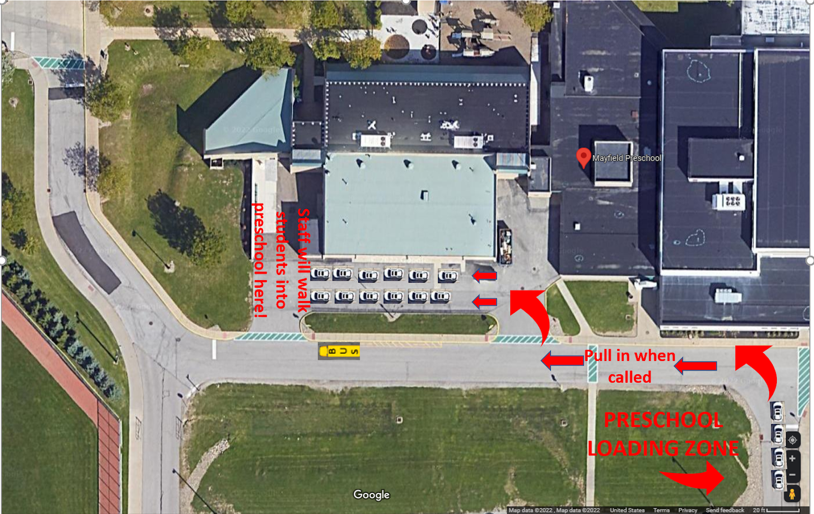
TRANSPORTATION
Special needs students may request district transportation during the IEP process.
Parents/Guardians provide transportation for Peer Models.
ATTENDANCE
Teachers will be taking attendance at the start of the school day. If your child will be late or absent please enter an Infinite Campus request; Call Mrs. C in the office 440-995-7300 scastellarin@mayfieldschools.org and/or email your child (ren's) teacher(s).
- It is expected that promptness and good attendance will be maintained. All possible effort should be made to schedule appointments and vacations when school is not in session.

- Notify Mrs. Zanella in the office 440-995-7300 kzanella@mayfieldschools.org
  - Appointment known in advance or impromptu during session
  - Going on vacation with your child
  - Parents going on vacation and leaving student at home - provide dates and caregiver information
- Extended Absence call Mrs.Zanella in the office 440-995-7300 scastellarin@mayfieldschools.org A district form must be completed.
SNACK
Each student is asked to bring their own water bottle daily with their name clearly marked on it. Students are provided time to have a snack daily. Parents/Guardians are expected to send in a healthy snack on a daily basis. As suggested by the regulation 3301-37-09, please provide a snack from two food groups.
Fruits (washed & cut up so it’s ready to eat)
Vegetables (washed & cut up so it’s ready to eat)
Healthy Grains
- Whole-grain crackers like Triscuits, which come in different flavors
- Dry cereals such as Cheerios (low in sugar)
- Rice cakes
- Popcorn (low fat)
Low-Fat Dairy Foods
- Yogurt (low fat and sugar)
- Low-fat cheese (string cheese is lots of fun)
- Pudding (made with skim milk)
BEHAVIOR
See State of Ohio Preschool Regulation Ohio Administrative Code Rule 3301-37-10 Behavior Management/Discipline
(A) A preschool staff member in charge of a child or a group of children shall be responsible for their discipline.
(B) The center shall have a written discipline policy describing the center's philosophy of discipline and the specific methods of discipline used at the center. This written policy shall be on file at the
center for review. Constructive , developmentally appropriate child guidance and management techniques are to be used at all times, and shall include such measures as redirection, separation from problem situations, talking with the child about the situation, and positive reinforcement for appropriate behavior. The center's written discipline policy is to comply with this rule, section
3319.46 of the Revised Code and rule 3301-35-15 of the Administrative Code.
(C) Behavior management/discipline policies and procedures shall ensure the safety, physical, and emotional well-being of all individuals on the premises. If suspension, expulsion, and removal policies exist, they are to be written in accordance with section 3313.66 of the Revised Code.
(D) The center's actual methods of discipline shall apply to all persons on the premises. In addition to the restrictions outlined in rule 3301-35-15 of the Administrative Code, the following apply:
(1) There shall be no cruel, harsh, corporal punishment or any unusual punishments such as, but not limited to, punching, pinching, shaking, spanking, or biting.
(2) No discipline shall be delegated to any other child.
(3) No physical restraints shall be used to confine a child by any means other than holding a child for a short period of time, so the child may regain control.
(4) No child shall be placed in a locked room or confined in an enclosed area such as a closet, a box, or a similar cubicle.
(5) No child shall be subjected to profane language, threats, derogatory remarks about himself or his family, or other verbal abuse.
(6) Discipline shall not be imposed on a child for failure to eat, failure to sleep, or for toileting accidents.
(7) Techniques of discipline shall not humiliate, shame, or frighten a child.
(8) Discipline shall not include withholding food, rest, or toilet use, and food shall not be used as a reward for behavior.
(9) Separation, when used as discipline shall be brief in duration and appropriate to the child's age and developmental ability, and the child shall be within sight and hearing of a preschool staff member in a safe, lighted, and well-ventilated space.
(10) The center shall not abuse or neglect children and shall protect children from abuse and neglect while in attendance in the preschool program.
(11) A staff member who suspects that a child has been abused or neglected is to immediately notify the public children services agency and a serious incident report is to be completed and submitted to the department in accordance with section 2151.421 of the Revised Code.
(E) The parent of a child enrolled in a center shall receive the center's written discipline policy. The center is to communicate and consult with the parent prior to implementing a specific behavior management plan. This plan will be consistent with this rule and in writing and signed by the parent.

The center’s actual methods of discipline shall apply to all persons on the premises and shall be restricted as follows: 1. There shall be no cruel, harsh, corporal punishments such as, but not limited to, punching, pinching, shaking, spanking, or biting. 2. No discipline shall be delegated to any other child. 3. No physical restraints shall be used to confine a child by any means other than holding a child for a short period of time, such as in a protective hug, so the child may regain control. 4. No child shall be placed in a locked room or confined in an enclosed area such as a closet, a box, or a similar cubicle. 5. No child shall be subjected to profane language, threats, derogatory remarks about himself or his family, or other verbal abuse. 6. Discipline shall not be imposed on a child for failure to eat, failure to sleep, or for toileting accidents. 7. Techniques of discipline shall not humiliate, shame, or frighten a child. 8. Discipline shall not include withholding food, rest, or toilet use, and food shall not be used as a reward for behavior. 9. Separation, when used as discipline shall be brief in duration and appropriate to the child’s age and developmental ability, and the child shall be within sight and hearing of a preschool staff member in a safe, lighted and well-ventilated space. 10. The center shall not abuse or neglect children and shall protect children from abuse and neglect while in attendance in the preschool program.
If behavior problems persist, an individual behavior management program will be developed with parent participation. Ongoing discussions will occur to review possible solutions and alternatives.
Positive Behavior Interventions and Supports (PBIS)/Discipline Policy
PBIS: Positive Behavior Intervention and Supports is an approach to supporting, teaching and developing students problem solving to be successful in school. School-Wide PBIS focuses on proactive curricula that teaches students shared language and expectations to provide supportive behavior/social emotional learning curriculum. These are proactive practices that prevent behavior by promoting expected behaviors by setting norms for students that improve school climate and culture. Mayfield Preschool focuses on teaching students through weekly lessons, stories and activities and reinforcing our PBIS expectations.
Mayfield City Schools Preschool will use developmentally appropriate child guidance and management techniques which are in alignment with the Mayfield City Schools’ PBIS policies and frameworks. These include such measures as redirection, separation from problem situations, talking with a child about the situation and expected vs. unexpected behaviors, using social stories, and praise for appropriate behavior. PBIS is an instructional approach to teaching social skills through the use of systematic and individual strategies. It is designed to build positive relationships among all school stakeholders and to present unexpected behavior outcomes. PBIS established clear expectations for behavior. Behavior management/discipline policies and procedures shall ensure the safety and well being of all individuals on the premises.
Mayfield Preschool Cubs are Cooperative, Understanding, able to Be Response and Safe.

SHARING INFORMATION
Young children are often affected by events and changes in their environment. In order to help your child deal with changes, please keep us informed of any events such as:
Illness or hospitalization of family members
- Pregnancies and births
- Death of family members or close friends
- Changes in family structure within the home
- Extra stimulation such as visitors or celebrations
- Plans for moving

CHANGE OF ADDRESS/CHANGE IN DIRECTORY INFORMATION
In the event that you need to change your address, please login to your parent portal and update your directory information and contact the registrar at the district office.

PARENT INVOLVEMENT
We believe parent participation is a vital component of a child’s school experience. Parents provide valuable input that helps to ensure a successful transition between home and school.
- Communication, questionnaires and checklists from the staff provide important information about your child.
- Parent conferences are held in the fall and in the spring. Additional conferences may be scheduled at the request of the parent or teacher.
- Communication between home and school is vital and may be in the form of notes, emails, see-saw app, and face-to-face conferences.
- School folders are sent home weekly. It may include notices from the school district, school and teacher. Please review and return the folder with any notes from home.
- Preschool parents are asked to complete a survey at the beginning and end of year to assist in program planning and implementation.
- Parent workshops are conducted throughout the school year. Topics are chosen from interests and issues expressed by the parents via a survey.
- Parents may coordinate all-school activities through Colleen Harrison.
- Parent volunteers are a vital resource. If you wish to volunteer in any part of the school, please contact the office 440-995-7300. There is a process that anyone volunteering in a classroom must follow.
STUDENT RELEASE
All authorized persons to pick up your child from the school must be in the Parent Portal on Infinite Campus. Should your child need to be picked up for any reason including regular dismissal, early dismissal, injury at school, etc, your child will only be released to people who are listed. People authorized to pick up the child must provide a valid drivers license or similar identification before the child is released. This is for the protection of our students.
IF INJURED AT SCHOOL:
- The primary contact on infinite campus will be contacted, and we will continue to phone emergency contacts in the order listed by the parent in the Parent Portal. A log of all incidents/injuries is kept, and details will be provided to the caregiver.
INFINITE CAMPUS
Infinite Campus is used for
Registration
ALL contact information updated yearly and as needed
Payments: tuition – fees
Principal Newsletter & Communication with district and school
SCHOOL CLOSING AND DELAYS
Cancellation of school takes place only during circumstances such as extreme weather or equipment failure. The School Board and administrators are aware of the hardship which can be caused by an abrupt cancellation. Therefore, school will not be canceled unless a significant safety risk has been created by unusual circumstances. Notification is thru Infinite Campus preferences: email, text, telephone
Please be sure your Infinite Campus contacts are kept up to date.
Cancellation of school: Mayfield City School District closing information may be heard on any one of the following television and radio stations: Ohio News Network, WKYC Channel 3, WEWS Channel 5 - Newsnet5, PAX 23 News, TV FOX 8 – WJW Channel 8, WOIO Channel 19, WUAB Channel 43, WTAM 1100, WGAR 99.5, WHLO 640, WKDD 98.1, MAJIC WMJI 105.7, WMMS 100.7, MIX 106.5, KISS 96.5, WCRF 103.3, WELW – AM 1330.

WITHDRAWAL
Withdrawal Form is used to notify the school of enrollment withdrawal. Please complete and return to the Preschool Office.
Other Information
Mayfield Preschool Staff websites and contact information are found on line at:
www.mayfieldschools.org/preschool.aspx
or
www.mayfieldschools.org è Home è Programs è Mayfield Preschool Program

